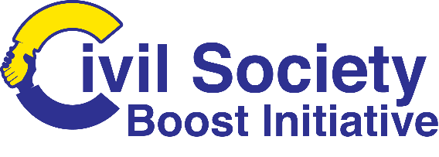

FINANCIAL SUPPORT TO THIRD PARTIES
for projects that contribute to
REDUCTION OF VIOLENCE AGAINST WOMEN & YOUTH

CALL for PROPOSALS & CONCEPTS
2024/CSBI/RLMS

CONTRACTING AUTHORITY: RISE Life Management Services
GUIDELINES TO APPLICANTS

Deadline for Submission:
May 24, 2024, 4:30 p.m. local date and time
APPLICATION FORM FOR CONCEPT NOTE (LOT 2 ONLY)

GRANTEE INFORMATION
Name of Applicant
Address
Name of Authorized Representative/s
E-mail Address/website
Telephone Number/s

GRANT INFORMATION
Name of project
Location where activities will be implemented | Parish: |  |  |  | Community/ies
Duration of project

BUDGET SUMMARY (a detailed budget is NOT required for this submission)
 | Local Currency (JMD)
Amount Requested
Cost-share amount
Total Budget

applicant Capability and past performance (Please provide a brief narrative describing your organization’s mission and primary activities, and also list training you have been involved in towards increasing your capacity to administer projects)
Organizational Background Narrative

Past Performance (Please describe one major project in which your organization was involved in the past two years, which shows the organization’s expertise and ability to meet the goals of the proposed project.)
First Project (if applicable)
Project Title
Period of Performance
Location
Role of Organization (leader or partner)
Project Objectives
Total Budget
Funding Source and Contact Information

Statement of Liability
I, the undersigned, being the person responsible in the applicant organization for this project, certify that the information given in this application is true and accurate.
Name
Position
Signature
Date

DESCRIPTION of the project:
Background/Rationale/Problem Statement (Please provide a brief and necessary background information on the issues and the problems that the proposed grant will address.)
Goals and Objectives (Please state the goal and its corresponding objectives to address the problems identified above.)
Goal:
- Objective 1
- Objective 2
Summary (Please provide a brief summary of the proposed project)
Technical Approach/Strategy (describe the approaches you will take to implement the project successfully)
Activities (Please provide a detailed description of all the activities to achieve each objective. Explain the logical connection between the proposed activities and the fulfillment of objectives.)
Beneficiaries (Please describe the type and number of beneficiaries as well as their needs and constraints.)

Before sending your CONCEPT NOTE, please check that each of the following criteria HAVE BEEN MET IN FULL AND TICK THEM OFF. Please remember to submit this document along with your CONCEPT NOTE. | Tick the items off below
Title of the Proposal: <indicate the title> | Yes | No
PART 1 (ADMINISTRATIVE)
1. The correct application form has been used.
2. The concept note is typed and is in English
PART 2 (ELIGIBILITY)
5. The duration of the project is between 6 months and 9 months (the minimum and maximum allowed).
6. The requested contribution is between 1, 000,000 JMD and 1, 500,000 JMD
7. The requested contribution is between 80 % and 95 % of the estimated total eligible costs (minimum and maximum percentage allowed).

