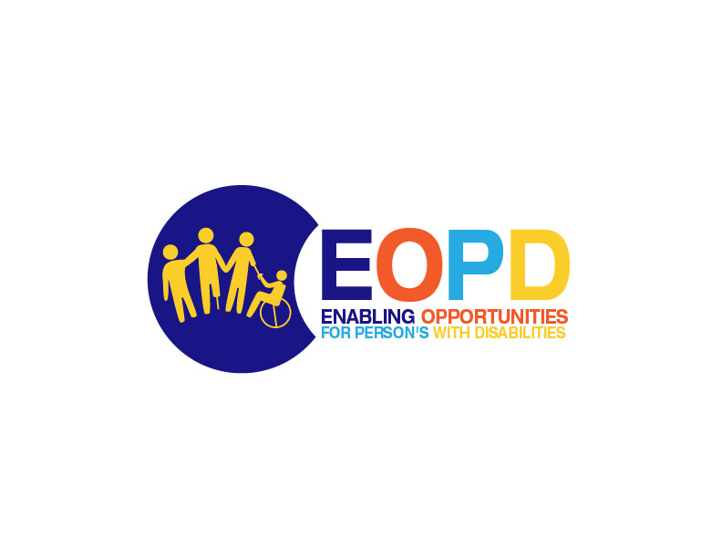
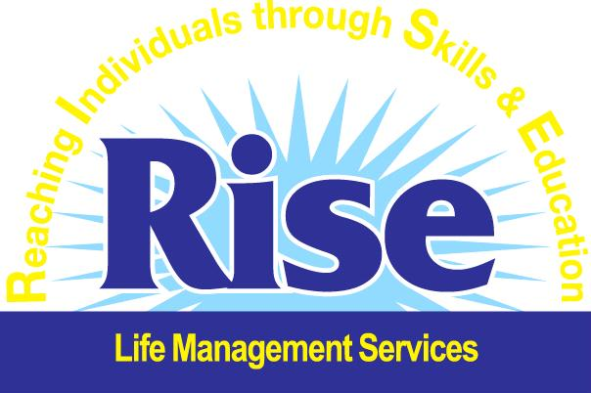

Contracting Authority: RISE Life Management Services

Enabling Opportunities for Persons with Disabilities
FINANCIAL SUPPORT TO THIRD PARTIES:
Supporting local organizations to provide opportunities to improve the Social & Economic rights of Persons with Disabilities

CALL for PROPOSALS

2022/EOPD/RLMS

Guideline to Applicants

Deadline for Submission of Proposals:
July 25, 2022, 4:00 p.m. Jamaican time

Information session for Applicants: June 21, 2022, 10:30 a.m. – 12 noon
(held virtually)

1. Background to Action
One billion people, or 15% of the world’s population, experience some form of disability, and disability prevalence is higher for developing countries. Persons with disabilities are more likely to experience adverse socioeconomic outcomes such as less education, poorer health outcomes, lower levels of employment, and higher poverty rates. Poverty may increase the risk of disability through malnutrition, inadequate access to education and health care, unsafe working conditions, a polluted environment, and lack of access to safe water and sanitation. Disability may also increase the risk of poverty, through lack of employment and education opportunities, lower wages, and the increased costs of living with a disability.
As COVID-19 continues to have wide-reaching impacts across the globe, it is important to note how persons with disabilities are impacted by the pandemic, including in the areas of health, education, and transportation. In the area of health, many persons with disabilities have additional underlying health needs that make them particularly vulnerable to severe symptoms of COVID-19, if contracted. Persons with disabilities may also be at increased risk of contracting COVID-19 because information about the disease, including the symptoms and prevention, are not commonly provided in accessible formats such as print materials in Braille, sign language interpretation, captions, audio provision, and graphics.
With widespread school closures, children with disabilities have lacked access to basic services such as meal programs; assistive technologies; access to resource personnel; recreation programs; extracurricular activities; and water, sanitation, and hygiene (WASH) programs. COVID-19 has led to a sudden shift in the role of the parent/caregiver to act simultaneously as teachers. It has also exacerbated the digital divide between learners as it relates to access to equipment, electricity, and the internet.
Barriers to full social and economic inclusion of persons with disabilities include inaccessible physical environments and transportation, the unavailability of assistive devices and technologies, non-adapted means of communication, gaps in service delivery, and discriminatory prejudice and stigma in society.
There is increasing global awareness of and demand for disability-inclusive development. The United Nations Convention on the Rights of Persons with Disabilities (CRPD) promotes the full integration of persons with disabilities in societies. The CRPD specifically references the importance of international development in addressing the rights of persons with disabilities.
The 2030 Agenda for Sustainable Development clearly states that disability cannot be a reason or criteria for lack of access to development programming and the realization of human rights. The Sustainable Development Goals (SDGs) framework includes seven targets which explicitly refer to persons with disabilities, and six further targets on persons in vulnerable situations, which include persons with disabilities.
A review of the Social and Economic Inclusion of Persons with Disabilities (SEIP) Project, which promotes training and job placements for persons of working age, found that of the 123 individuals who received job placements upon the initiation of the Project in 2013, only 17% were still employed six months after completing training (World Bank, 2016). According to the 2001 census, 2.7% of the Jamaican population has a hearing loss, approximately 75,000 people. The deaf community in Jamaica is faced with education, employment, social acceptance, and integration challenges. Many deaf Jamaicans, qualified and unqualified, skilled, and unskilled, have difficulty securing employment. Several deaf persons take years to land a job as employers are afraid, skeptical and not equipped to hire them. Education and employment challenges faced by deaf persons predisposes them to unemployment, poverty, victimization and slowed or stalled progress in their social mobility. The socioeconomic impacts of Covid-19 such as job loss, business closures, reduced or lost income, has exacerbated challenges facing the deaf and underscores the need for interventions to address these challenges
The economic fallout in Jamaica as a result of the coronavirus outbreak has become evident for the poorest of Jamaicans, and while the Government has implemented stimulus programmes, there will be need for support to establish economic activities toward financial recovery among the most vulnerable. This is the basis for the current Call for Proposals.
The Enabling Opportunities for Persons with Disabilities is a 24-month action with the main objective of ensuring persons with disabilities (PWD) are fully integrated in society, have access to appropriate care and support services, and are treated as valuable human resources. The project includes the following specific objectives to be achieved over the duration of the project:
- Raising public awareness and combating stereotypes regarding persons with disabilities through a national media campaign
- Providing Jamaican sign language training for youth volunteers, Civil Society Organizations (CSOs), and 100 persons from key government ministries, departments, and agencies that interact with the deaf.
- Providing life skills training and psychosocial support for selected children, youth and abused women with disabilities.
- Providing vocational skills training that lead to employment for 100 persons with disabilities.
- Supporting local disability organization/s (through sub-granting) to provide appropriate Covid-19 responses for persons with disabilities.
- Strengthening CSO response to the promotion of the rights of persons with disabilities by supporting the newly established Civil Society Network.

2. Objective and Priority Issues of the Call for Proposals
The following objective MUST be achieved:
To increase economic opportunities for persons with disabilities
In accordance with the objective, the priorities of this call for proposals are as follows:
a. Actions that increase access to economic empowerment for persons with disabilities,
particularly women.

b. Actions to increase access to safety and violence prevention services for persons with disabilities while increasing their capacity to earn a living

c. Actions that build the income generation capacity of agencies tasked with providing care and support of persons with disabilities.
3. Financial Allocation Provided
RISE reserves the right not to award all available funds. Any grant requested under this Call for Proposals must fall between the following minimum and maximum amounts:

Minimum amount: JMD 1,600,000
Maximum amount: JMD 3,200,000
Any grant requested under this Call for Proposals must fall between the following minimum and maximum percentages of total eligible costs of the action:
Minimum percentage: 70%
Maximum percentage: 95%

For example: If your total budget is J$6,000,000 and you are requesting the maximum under this call (J$3, 200, 000), the percentage of our contribution would be approximately 53%. As a result, this action will not be eligible for funding as the percentage contribution requested falls below the minimum. Alternatively, for actions requesting the maximum amount ($3, 200, 000), the maximum total eligible cost of your proposed budget must be JMD 4, 571, 428.57. This allows for your request of $3, 200, 000 to be at least 70% of the total budget of the project.

PLEASE NOTE:
The BALANCE, that is, the minimum amount of 30% or the maximum amount of 5% (difference between the total cost of the action and the amount requested from RISE) MUST BE FINANCED FROM SOURCES OTHER than the European Union Budget or the European Development Fund, or any RISE related funding streams.
4. Duration & Location
The duration of the action may not be less than 6 months nor exceed 9 months.
Actions must take place in Jamaica and target marginalized, vulnerable persons with disabilities. Applicants are required to demonstrate this in their submission.
5. The following types of activities are examples of what may be financed under this Call for Proposals
- capacity building of agencies providing services to persons with disabilities.
- development of income generating activities that benefit persons with disabilities, primarily women.

6. You MAY NOT SUBMIT A PROPOSAL with any of the following activities:

- Actions treating mainly with media campaigns. Actions may include social media promotion of activities as a means of visibility for their activities, but a social or mass media campaign may not be the sole or main purpose of the action.
- Provision of sign language training. If, in carrying out particular activities, it becomes necessary for the applicant to provide sign language training for staff or volunteers, that is foreseeable. However, the provision of sign language training may not be the sole or main purpose of the action.
• Provision of life skills training and psychosocial support for children, youth, and abused women with disabilities, may not be the sole or main purpose of the call.
• Provision of vocational skills training.
• Third-party financial support to other organizations.
- Development of new micro enterprises associated with PWDs.
• Formation of CSO networks.

7. Types of organizations or categories of persons which may apply
Applicants must be a legal entity operating in Jamaica as a Non-Profit Organization working with and for persons living with disabilities.

8. Proposals per applicant

- The applicant may not submit more than one application under this Call for Proposals.
- The applicant may, however, be a co-applicant in another application at the same time.
- An applicant/co-applicant may not be awarded more than one grant under this Call for Proposals.

9. Eligibility of Costs
Eligible Direct Costs

The following direct costs of the Beneficiary shall be eligible and may be included:
- The costs of staff assigned to the Action, corresponding to actual gross salaries including statutory charges and other remuneration-related costs; salaries and costs shall not exceed those normally borne by the beneficiary.
- Travel and subsistence costs for staff and other persons taking part in the action provided they are rational and do not exceed those normally borne by the Beneficiary.
- Purchase costs for equipment and supplies specifically for the purpose of the Action.
- Costs of consumables.
- Duties, taxes and charges, including GCT paid and are not recoverable by the Beneficiary.
- Overhead Costs
Contingency Reserve

The budget may include a contingency reserve not exceeding 5% of the estimated direct eligible costs. It can only be used with the prior written authorization of RISE Life Management Services.

Eligible Indirect Costs
The indirect costs incurred in carrying out the action may be eligible for flat-rate funding, but the total must not exceed 7 % of the estimated total eligible direct costs. Indirect costs are eligible provided that they do not include costs assigned to another budget heading. Once the flat rate has been fixed in the special conditions of the standard grant contract, no supporting documents need to be provided.

Contributions in kind
Contributions in kind mean the provision of goods or services to a Beneficiary(ies) or affiliated entity(ies) free of charge by a third party. As contributions in kind do not involve any expenditure for a Beneficiary(ies), they are not eligible costs.

Contributions in kind may not be treated as co-financing. However, if the description of the action as proposed includes contributions in kind, the contributions have to be made.

Ineligible costs

The following costs are not eligible:

- debts and debt service charges (interest);
- provisions for losses or potential future liabilities;
- costs declared by the Beneficiary(ies) and financed by another action or work programme receiving a European Union (EU) (including through EDF) grant;
- purchases of land or buildings, except where necessary for the direct implementation of the action, in which case ownership must be transferred to the final beneficiaries and/or local Beneficiary(ies), at the latest at the end of the action;
- currency exchange losses;
- credit to third parties;
- salary costs of the personnel of national administrations.
Financial Support to Third Parties is NOT allowed under this Call for Proposals.

10. Visibility

The Applicant must take all necessary steps to publicize the fact that the European Union and RISE Life Management Services have financed or co-financed the Action. As far as possible, actions that are wholly or partially funded by the European Union must incorporate information and communication activities designed to raise the awareness of specific or general audiences of the reasons for the action and the EU support for the action in the country or region concerned, as well as the results and the impact of this support.

11. Information about Applications

An Information Session on this Call for Proposals will be held on June 21, 2022, 10:30 a.m. – 12 noon local time (held virtually) Please confirm your attendance to this session by sending email to info@risejamaica.org using the following subject heading: Information Session – EOPD. A confirmation message containing meeting information will be sent to you.
In addition, questions may be sent by e-mail no later than 10 days before the deadline for submission of applications (July 15, 2022), to the following email address: info@risejamaica.org, with subject heading: Questions re EOPD Call for Proposal. Responses to these questions will be provided.
RISE has no obligation to provide clarifications to questions received after this date. Replies will be given no later than 10 days before the deadline for submission of applications. All questions and their responses will be published on the RISE Life Management Services website http://www.risejamaica.org on July 17, 2022. It is therefore advisable to consult the abovementioned website regularly in order to be informed of the questions and answers published.
To ensure equal treatment of applicants, RISE cannot give a prior opinion on the eligibility of applicants, an action, or specific activities.
12. Submission of Applications
THE DEADLINE FOR THE SUBMISSION OF APPLICATIONS is Monday, July 25, 2022, at 4 p.m. Jamaica time. Applications submitted after the deadline will not be evaluated.
What to Submit:
You must submit the following documents:
Full Proposal (using Application Form to be found on the RISE website)
Budget (done in Excel and using form on the RISE website)
Proof of Registration (either Companies Office or Department of Cooperatives & Friendly Societies)
Audited Financial Statements (up to three years)
Where and how to send Applications
Applications, inclusive of budget must be submitted to the following e-mail address: info@risejamaica.org.
The email must bear the following subject: Attn: Enabling Opportunities for Persons with Disabilities, Call for Proposals/2022/EOPD/RLMS

Evaluation & Selection of Applicants
Applications will be examined and evaluated by RISE with the possible assistance of external assessors. All proposals submitted will be assessed according to the following criteria:
Step 1: OPENING & ADMINISTRATIVE CHECKS
(To be done under the observation of EU representative)
The following will be assessed:
Step 1: Administrative Checks

- Compliance with the submission deadline. If the deadline has not been met, the application will be automatically rejected.

b. Checks that the Applicant is duly registered in Jamaica and is a legal entity.

Step 2: EVALUATION OF PROPOSALS

The evaluation criteria are divided into sections and subsections. Each subsection will be given a score between 1 and 5 as follows: 1 = very poor; 2 = poor; 3 = adequate; 4 = good; 5 = very good.

Section | Maximum Score
1. Financial and operational capacity | 30
1.1 Do/es the applicant/s and, if applicable, their affiliated entity(ies) have sufficient experience of project management? | 10
1.2 Do/es the applicant/s and, if applicable, their affiliated entity(ies) have sufficient technical expertise? (Especially knowledge of the issues to be addressed)? | 5
1.3 Do/es the applicant/s and, if applicable, their affiliated entity(ies) have sufficient management capacity? (Including staff, equipment and ability to handle the budget for the action)? | 5
1.4 Does the lead applicant have stable and sufficient sources of finance? | 10
2. Effectiveness and feasibility of the action | 35
2.1 How relevant is the proposal to the objectives and priorities of the call for proposals and to the specific themes/sectors/areas or any other specific requirement stated in the guidelines for applicants? | 5X2**
2.2 Are the activities proposed appropriate, practical, and consistent with the objectives and expected results? | 5
2.3 How clearly defined and strategically chosen are those involved (final beneficiaries, target groups)? Have their needs and constraints been clearly defined and does the proposal address them appropriately? | 5
2.4 Is the action plan clear and feasible? | 5
2.5 Does the proposal contain objectively verifiable indicators for the outcome of the action? Is any evaluation planned? | 5
2.6 Does the proposal contain particular added-value elements (e.g. innovation, best practices) ? Does the proposal contain sufficient visibility mechanisms to highlight the funding provided by RISE and the EU? | 5
3. Sustainability of the action | 20
3.1 Is the action likely to have a tangible impact on its target groups? | 5
3.2 Is the proposal likely to have multiplier effects? (Including scope for replication, extension, and information sharing.) | 5
3.3 Are the expected results of the proposed action sustainable?:  - financially (how will the activities be financed after the funding ends?)  - institutionally (will structures allowing the activities to continue be in place at the end of the action? Will there be local ‘ownership’ of the results of the action?)  - at policy level (where applicable) (what will be the structural impact of the action (e.g., will it lead to improved legislation, codes of conduct, methods, etc?)  - environmentally (if applicable) (will the action have a negative/positive environmental impact?) | 5X2**
4. Budget and cost-effectiveness of the action | 15
4.1 Are the activities appropriately reflected in the budget? | 5
4.2 Is the ratio between the estimated costs and the expected results satisfactory? | 5X2**
Maximum total score | 100
**: this score is multiplied by 2 because of its importance
Note on Section 1: Financial and Operational Capacity
If the total score for Section 1 is less than 12 points, the application will be rejected. If the score for at least one of the subsections under Section 1 is 1, the application will also be rejected.

Ethics Clauses and Code of Conduct
a) Absence of conflict of interest
The applicant must not be affected by any conflict of interest and must have no equivalent relation in that respect with other applicants or parties involved in the actions. Any attempt by an applicant to obtain confidential information, enter into unlawful agreements with competitors or influence the evaluation committee or the contracting authority during the process of examining, clarifying, evaluating and comparing applications will lead to the rejection of its application and may result in administrative penalties according to the Financial Regulation in force.
b) Respect for human rights as well as environmental legislation and core labour standards
The applicant and its staff must comply with human rights. In particular, and in accordance with the applicable Act, applicants who have been awarded contracts must comply with the environmental legislation including multilateral environmental agreements, and with the core labour standards as applicable and as defined in the relevant International Labour Organization conventions (such as the Conventions on Freedom of Association and Collective Bargaining; Elimination of Forced and Compulsory Labour; Abolition of Child Labour).
Zero tolerance for sexual exploitation, abuse, and harassment:
RISE Life Management Services applies a policy of 'zero tolerance' in relation to all wrongful conduct which has an impact on the professional credibility of the applicant.
Physical abuse or punishment, or threats of physical abuse, sexual abuse or exploitation, harassment and verbal abuse, as well as other forms of intimidation shall be prohibited.

c) Anti-corruption and anti-bribery
The applicant shall comply with all applicable laws, regulations, and codes relating to anti-bribery and anti-corruption. The Contracting Authority reserves the right to suspend or cancel project financing if corrupt practices of any kind are discovered at any stage of the award process or during the execution of a contract and if the Applicant fails to take all appropriate measures to remedy the situation. For the purposes of this provision, ‘corrupt practices’ are the offer of a bribe, gift, gratuity or commission to any person as an inducement or reward for performing or refraining from any act relating to the award of a contract or execution of a contract already concluded with the contracting authority.

d) Breach of obligations, irregularities or fraud
The Contracting Authority reserves the right to suspend or cancel the award procedure, where the award procedure proves to have been subject to substantial breach of obligations, irregularities or fraud. If substantial breach of obligations, irregularities or fraud are discovered after the award of the contract, the Contracting Authority may refrain from concluding the contract.

Notification of the Contracting Authority’s Decision
All applicants will be informed in writing of the Contracting Authority’s decision concerning their application and, if rejected, the reason for the negative decision.

Indicative Timetable

 | DATE | TIME*
Information Session | June 21, 2022 | 10:30 a.m. – 12 p.m./noon
Deadline for requesting any clarifications from RISE Life Management Services | July 15, 2022 | 12 p.m./noon
Last date on which responses to clarifications are issued by RISE Life Management Services | July 17, 2022 | 4 p.m.
Deadline for submission of applications | July 25, 2022 | 4 p.m. Jamaica time
Notification of award | August 10, 2022 | -
Contract signature | August 15, 2022 | -

This indicative timetable may be updated by RISE Life Management Services during the procedure. In such cases, the updated timetable will be published on the RISE Life Management Services web site www.risejamaica.org

World Bank, Disability Inclusion, April 14, 2022 https://www.worldbank.org/en/topic/disability#1

